Implement the SR Master-Slave flip flop on logic works. Also, show the timing diagram.

Note:

- Draw the Combinational Circuit diagram using NAND & NOT gates.
- For clock pulse (CP) use “clock” component available in Logic works.
- Label the diagram properly

Logic Diagram:

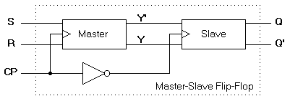

Timing Diagram:

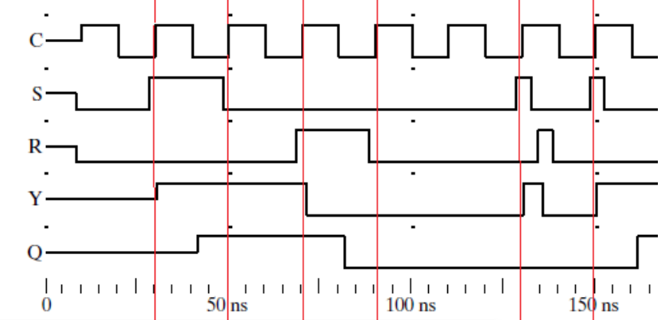

Perform on Logic Works and test the ICs of D-Flip flop & JK flip flop so that is fulfils their tables (get familiar with inputs & outputs)

Lab Task 3:

Perform on Logic Works by using IC of JK-Flip flop and construct master-slave flip flop using JK FF IC.

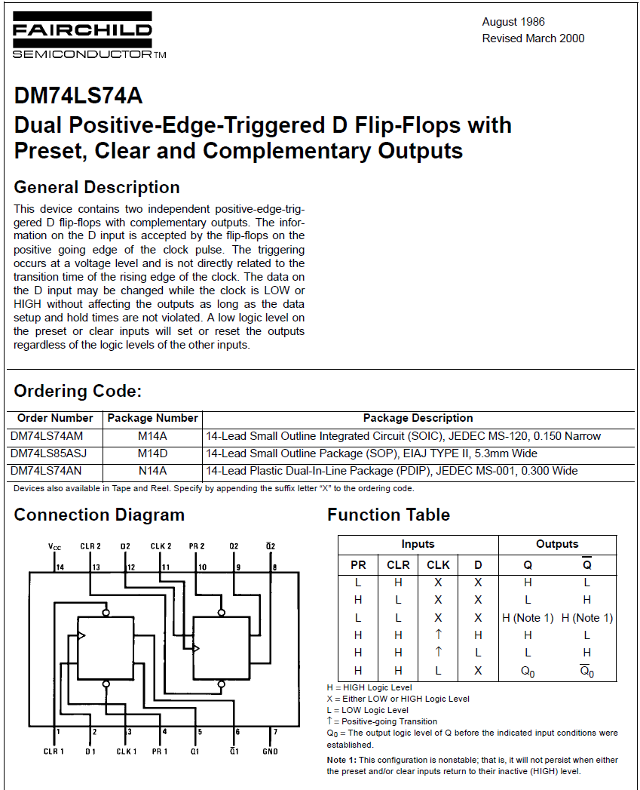

DFF IC

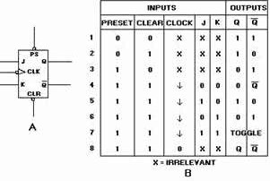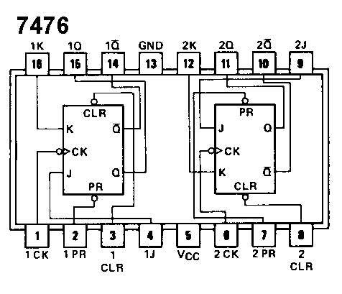

JK FF IC

